

IBM Global Services

SDS R3: Symbols Notation for the Operational Viewpoint

Guideline

© Copyright International Business Machines Corporation 2002, 2012

All Rights Reserved
Version 3.0, July, 2012

Brief Description
This document presents a standard notation for the symbols of model elements as they appear on views associated with the Operational Viewpoint of Architecture within IBM’s Unified Method Framework (UMF).
Section “About this Document” introduces the scope of these notations; explains why such a notation is needed and who might use it; and how the notation relates to the broader context of UMF.
Section “Operational Viewpoint Symbol Notations” describes the notations for each type of element (i.e. the shape and form of its symbol) as it appears on each type of view.

About this Document

Definitions and Conventions used in this Document
This document adopts UMF’s “model – viewpoint – view” approach to modeling (see [Ref 3]), in which:
A Model: Is a collection of descriptions and relationships that document the target IT system’s structure of parts and their behaviours.
A Viewpoint: Is an observational point-of-view looking onto the model - in other words, a definition of the types of parts of interest to the model’s observer – referred to as the stakeholder, together with a definition of how the stakeholder is to render these model views (i.e. the views’ notation).
A View: Is an actual "diagram", "sketch", "table", "matrix", "list", and even "picture" and "narrative" of parts of the model - anything an observer draws/writes/reads as a representation of some part of the model from a viewpoint.
The essence of this approach lies in the distinction between a model, which may be stored in a manner that helps ensure its completeness and integrity whatever viewpoint it is observed from; and individual sets of views of the model which are designed to convey meaning to a specific type of observer, such as diagrams, sketches and lists within a “report”.
Keeping this distinction between “the model” and “views of the model” is a critical success factor in ensuring a target IT System’s design evolves in a cohesive and coherent way, with all model changes (achieved from any viewpoint) are faithfully rendered in all views from all viewpoints.
In UMF, the definition of a model’s standard viewpoint is part of each UMF artifact (which includes other stakeholder concerns such as development guidance and development time estimates), while the “report” presenting the set of views of an actual model from that viewpoint is part of the project’s artifact.
UMF uses the same name for the standard viewpoint and for a project’s view of its target IT system from that viewpoint; for example “Node Model” and “Operational Model”:
- In UMF
- The Node Model artifact description (ART 0524) includes definitions of the operational viewpoint’s views’ notations expected to be in a project’s node model report.
- The Operational Model artifact description (ART 0502) includes definitions of a different set of the operational viewpoint views’ notations that are expected to be in a project’s operational model.
- On a project
- The “Node Model” artifact includes a collection of views of the project’s target IT system’s model when it’s observed from the UMF Node Model artifact’s operational viewpoint.
- The “Operational Model” includes a different collection of views of the same target IT system model when that can be seen from the UMF Operational Model artifact’s operational viewpoint.
[Ref 3] provides a full discussion on models, views and viewpoints, while [Ref 4] offers a detailed discussion on how UMF’s operational viewpoint artifacts define a suite of “secondary” operational viewpoints.

Scope
The development and documentation of the operational viewpoint of a target IT system’s model is captured via a family of operational modelling artefacts that allow the Architect to reason about:
- The operational “black box” context of the target IT system via its actors/users and their access mechanisms, in the operational views of the target IT system’s System Context
- The “white box” parts that make up the target IT system:
- The various aspects of the functional viewpoint’s components that need to be deployed, usually modeled as deployment units (DUs), documented in the target IT System’s Deployment Unit Model.
- The platforms that may be used to support these DUs, modelled as nodes and connections and documented in its Node Model
- The places these DUs, nodes and other parts of the target IT system can be located, represented by locations and borders and documented in its Location Model.
- The actual deployment, structure and behaviour of these parts, documented in the target IT system’s Operational Model
This notation guidance document defines standard symbols for these and other model elements as they appear on various types of view, as defined in the corresponding artefact descriptions in UMF:
- System Context (ART 0651),
- Deployment Unit Model (ART 0525),
- Location Model (ART 0523),
- Zone Model (ART 0511),
- Node Model(ART 0524),
- Operational Model (ART 0502)
These notations must be used whenever the operational viewpoint’s views are drawn formally (i.e. rather than as “sketches”). Any deviation or addition to this notation must be highlighted either via a key on the view or in supporting text. Additionally, there may be circumstances in which the following artifacts can benefit from these formal notations:
- Technical Environment (ART 0506),
- Architecture Overview (ART 0512)
It is also probable that this notation will be of use for symbols representing these model elements in other artefacts, such as the Performance Model and Software Distribution Plan.

Out of Scope
Certain aspects of the operational viewpoint are out of scope of this notation:
Element Specification: While this notation may provide visual clues to key characteristics of the target IT system’s model’s elements (such as the use of different icons for human or IT system actors, or colour coding and font choice for security requirements), it does not offer a means of portraying all properties and characteristics of each element. Element characteristics are typically documented via tables and other supporting text, which is out of scope of this drawing notation.
View Layout: This notation defines the manner in which the target IT system’s model’s elements’ symbols are drawn on many different types of views. It does not, however, direct the modeller on how each view should be “composed” of these symbols. This is defined individually, for each type of view, in the “notation” section of each UMF artifact, as well as being aggregated in one place, in [Ref 1].
Network Diagrams: One of the purposes of producing views of the target IT system from the operational viewpoint is to provide the information necessary for the subsequent activities of network design. Although it is normal for the operational viewpoint to represent the location and relationships between hardware and software technologies, including routers, firewalls and the like, the operational viewpoint’s views do not directly provide the necessary detail for network configuration.
System Configuration: Similarly, although the operational viewpoint can provide a specification of the technologies required to implement an IT system, its views do not provide detailed physical hardware design information, such as the number of disk packs on a computer or rack layout, nor detailed software design.

When to use this Notation
This notation
- Will help Architects to work with reduced risk of misinterpretation, and enhancing the usability of Reference Architectures and other intellectual capital by ensuring Architects can construct unambiguous operational viewpoint views of their target IT system.
- Provides a means of documenting a model of the target IT system independently of the techniques used in its construction. Some established techniques do, however, require variations in the way OM diagrams are drawn. If this causes a change in the required notation, then this change is included in this document.

Circumstances requiring care
This is a very rich notation, capable of supporting a very full and complex representation of the operational viewpoint’s views. Although documented as a series of precise statements about how the target IT system’s parts must be drawn from the operational viewpoint, it must not stop diagrams being drawn using variations on this standard. It can therefore be necessary to exercise judgment in its use, to balance the unambiguous presentation of information and clarity with the drawing capabilities of the tool and the capacity for readers to understand formal diagrams.
If, however, diagrams are drawn in a different way, then to avoid ambiguity and misunderstanding the manner in which they differ from the standard notation presented here must be noted via a key or some other mechanism.

Audience
This document is intended for all IT Architects engaged in the creation or use of artefacts associated with the operational viewpoint of architecture. It is also likely to be of interest to others who come into contact with the operational viewpoint and its associated artefacts, such as IT Architects focused on the functional viewpoint of the target IT system’s model, and IT Specialists working on its technological design.

SDS and the IBM Global Services Method
Notation forms part of the bridge between a formal language of architecture, such as IBM’s System Description Standard (SDS), and the practicalities of creating deliverables within a project such as those based on IBM’s UMF:
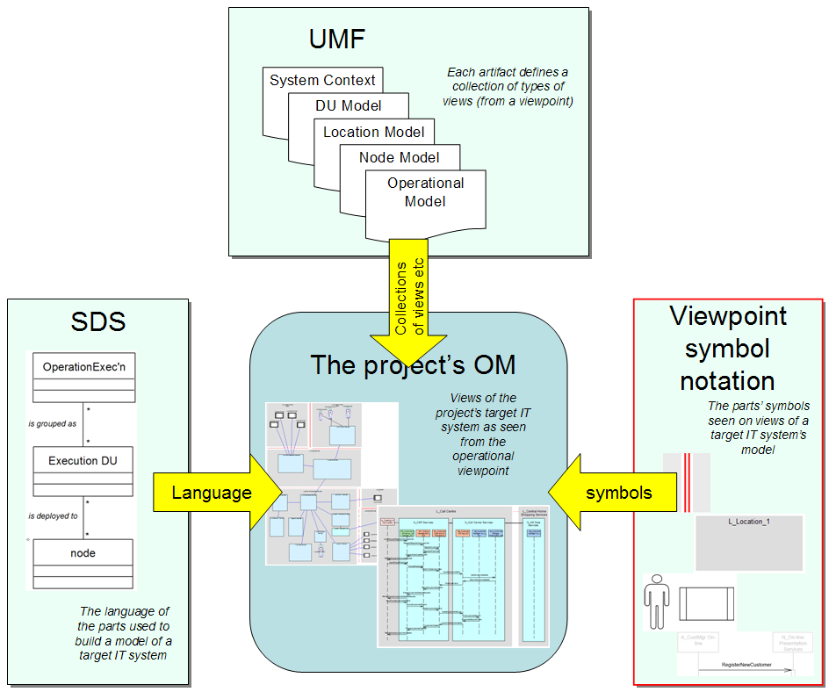
Figure 1: Relationship between IBM’s SDS, UMF and symbol notation

Figure 1 highlights how IBM’s formal approach to modelling supports the documentation of a target IT system’s model through:
- IBM’s System Description Standard, which provides formal definitions of the types of element the model can contain, together with the permitted relationships between these elements - such as what a Node is and how it is related to Deployment Units, Connections and the like.
- IBM’s Unified Method Framework, which provides a set of artifact definitions, each documenting how the target IT system’s model is to be presented from a particular viewpoint (such as the operational viewpoint).
- The standard notation offered here, which provides a universal way of drawing the symbols that represent these model elements on any and all views of the target IT system’s model as defined by the UMF artifact.

Notation and “Perspectives”
The artefacts associated with the operational viewpoint document the target IT system’s model using a number of “perspectives”, each of which may require some variation in the notation used for the model’s elements’ symbols:

Logical View: In which the required logical characteristics and capabilities of the target IT system’s model’s elements and their relationships are presented: the view is a “specification view” of the target IT system’s model.
Physical View: In which the physical technologies needed to deliver these characteristics and capabilities are identified and configured, whether they are to be bought (software packages and hardware) or developed (software development and bespoke hardware): the view is an “implementation view” of the target IT system’s model.

Structure View: In which a view documents the static relationships between the model’s elements.
Walkthrough View: In which a view documents the way the model’s elements interact, in order to support the dynamic requirements placed on the target IT system.

Application View: Representing elements in the target IT system on which the architect is focused - the views “seen” from their viewpoint.
Technical View: Representing the elements of the target IT system’s model needed to make “the application” work – technical views include elements needed by the target IT system’s model to achieve “the application’s” characteristics.

Non-located View: In which the target IT system’s model’s elements (sometimes types of element) are modelled without regard for where they are.
Located View: In which representative instances of the target IT system’s model’s elements are placed in or across the locations over which the system will be deployed

Unless specifically distinguished in the following sections, the core notation for the target IT system’s model’s symbols in the operational aspect’s views are:
- Are neutral to the first three of these perspectives, although there may be additional options whenever required for clarity or layout
- Represent “located model elements” and are therefore all “located views”.
The inter-relationships between these four pairs of views are discussed in detail in [Ref 1] and [Ref 4 & 5].

Operational Viewpoint Symbol Notations
The Operational Model artifact [is the central artifact that] describes the "operational aspect” of an IT system's architecture. It describes the required operational characteristics and capabilities of the IT system architecture and represents, at an architectural level, the network of computer systems and their associated peripherals, together with the systems software, middleware, and application software that they run in order to support the users of the system .
Operational Modelling helps the IT Architect understand where everything is and/or where everything should go, what it is doing or will do there, and what will be needed to help ensure the IT system continues to operate effectively and efficiently. [Ref 4]
Diagrammatic views of the operational viewpoint include symbols for the following model elements (note that these bullets link directly to the appropriate section of the document):
- Target IT System(N)
- Location (N)
- Border (C)
- Zone (N)
- External Agent (Actors and Users, N)
- Access Mechanism (C)
- Exchange (C)
- Node (N)
- Connection (C)
- Deployment Unit (N)
- DU Connector(C)
- DU and Freeform Message(C)
Those marked “N” are nodal model elements, whose symbols are generally shapes, icons or pictures, whereas those marked “C” are connective, whose symbols are generally lines. Note that these connective model elements’ line symbols must not be confused with inter-model element relationship lines.
The notation for symbols of each of these elements as seen on views from the operational viewpoint is presented in the following sections, following a consistent format:
- A brief definition.
- The core notation. In general, this notation does not require additional information to avoid ambiguity.
- Additional notation options. This optional notation may support:
- Variation by perspective: if it is appropriate to use different symbols for the element on views from different perspectives.
- Visually presented information: if it is appropriate to annotate or otherwise alter the model element’s symbol in order to convey some non-functional characteristic or other functional property.
Occasionally, use of an additional notation option will require its meaning to be documented as part of the view – for example, defining the value (or range of values) of the characteristic being highlighted.

Element Naming (All Model Elements)

Core Notation
The name of each type of model element and its symbol may be prefixed using short or long formats:
- Short form: XX<x> or XX_<short name> Long form: XX_<element name>
Where:
XX or XX_ replaced by a one or two letter prefix specific to the model element type
<x> a numeric identifier, which may take a “dotted decimal” form
<short name> an abbreviated form of the name, with or without “_” between words
<element name> the model element’s name, with or without “_” between words
Typically, long names are used in textual contexts, whenever reference is made to the model element. Short names are more commonly associated with model elements’ symbols on diagrammatic views, particularly when there is limited space on the view.

Additional Options

Engineering Perspective – names qualified by perspective
Names may be qualified by engineering perspective, such as:
- Logical model element: LXX<x> LXX_<short name> LXX_<element name>
- Physical model element: PXX<x> PXX_<short name> PXX_<element name>
- Application view model element: AXX<x> AXX_<short name> AXX_<element name>
- Technical view model element: TXX<x> TXX_<short name> TXX_<element name>
- Located model element names: LXX<x> LXX_<short name> LXX_<element name>
These may combine, such as:
- Logical located element: LLXX<x> LLXX_<short name> LLXX_<element name>
- Physical technical element: PTXX<x> PTXX_<short name> PTXX_<element name>
Precedence of perspective is usually:
- Logical / Physical
- Located
- Application/Technical

Visually Presented Information – standard prefix
Names may use the following standard prefixes:
- Target IT System TS_
- External Agent (logical) A_
- External Agent (physical) U_
- Access Mechanism AM_
- Location L_
- Border B_
- Zone Z_
- Node N_
- Connection C_
- Deployment Unit see section “Deployment Unit”
- DU connector DUC_
- Inter-DU Message DUM_
For example, for a node, using the prefix “N”:
- Short form (numeric) N1.2
- Short form (alpha) N_App_Svr
- Long form: N_Application Server

Visually Presented Information - enumeration
Any model element’s symbol appearing on a physical view may be enumerated, whether the number is appended to the name or as a number on or adjacent to the symbol, such as:
- XX_<short name> (1) when the model element is of one specific thing in the real world
- XX_<short name> (30) when it’s a model element representing a known number of instances
- XX_<short name> (N) when it’s a model element representing an unknown number of instances
For example, for physical locations, using the prefix “PL”:
- If there’s exactly one head office PL_AmGro House (1)
- If there;s 30 branch offices PL_Branch Office (30)
- If there’s an unknown number of service centres: PL_Service Centre (N)
Generally, numbers are cumulative, for example:
- A located node symbol “PLN_Home Shopping Server (2)” appearing inside physical location “PL_Service Centre (3)” means each service centre will contain two home shopping servers and a total of six home shopping servers will be required.
Some logical model elements (and therefore their symbols) may also be enumerated:
- Actors (on system context’s operational views)
- Located actors (on all other views)
- Logical locations

Symbol Labelling (All Model Elements)

Core Notation
None

Additional Options

Visually Presented Information – shape symbol name
For any “shape” symbol, the short form or long form name may be presented within the symbol, or adjacent to it:
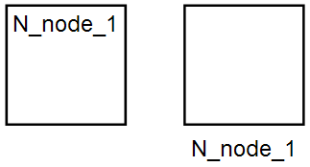
Figure 2: Typical “core notation” shape symbols showing name label (within, or adjacent)

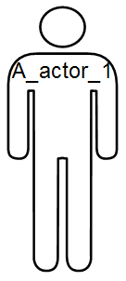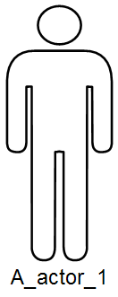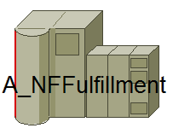
Figure 3: Typical “additional options” shape symbols showing name label (within, or adjacent)

Visually Presented Information – line symbol name
For any “line” symbol, the short form or long form name may be presented adjacent to the symbol:
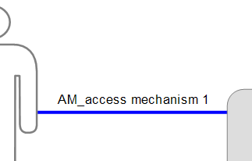
Figure 4: Typical “line” symbol showing name label

Visually Presented Information – additional model element properties
For any “nodal” model element’s symbol (i.e. shape), and most commonly for those of simple shape (e.g. core notations), critical properties may be documented within the symbol shape:
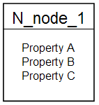
Figure 5: Typical “core notation” symbol showing additional properties

A similar requirement for a “connective” model element’s symbol (i.e. a line) can only be achieved via the display of key properties adjacent to the line:
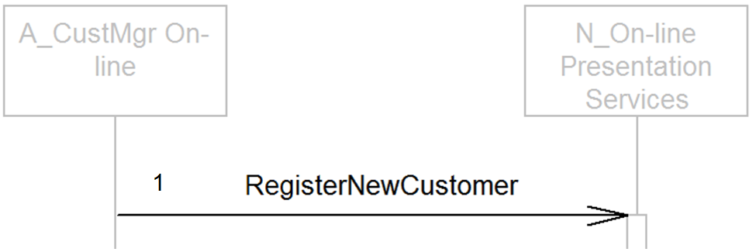
Figure 6: Typical “line” symbol showing additional property (sequence number)

Line Drawing

Core Notation
Except for DU message symbols on sequence views, all line symbols may either be drawn “point to point” at any orientation:
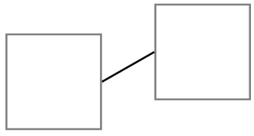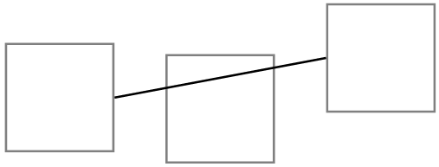
Figure 7: Typical “point-to-point” line symbols
Or drawn orthogonally, allowing them to be routed around intervening symbols:
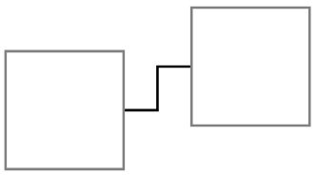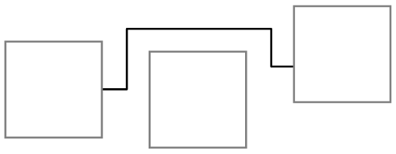
Figure 8: Typical orthogonal, routed” line symbols

DU Message symbols on sequence views must be drawn straight and horizontally.

Additional Options

Visually Presented Information – “connective” and “transport”
Some line symbols represent a “connective medium” between model elements, such as those for access mechanism, border or connection. Other line symbols represent a conversation or some other flow between model elements, such as those for an exchange or DU connector.
It may therefore help to distinguish connective model elements’ symbols by drawing them with thicker lines, and those for “transport” model elements with thinner lines.

Connective elements’ symbols and element relationships
In general, care is needed to distinguish the meaning of “lines” on diagrammatic views – they may represent connective model elements, or a relationship between two model elements:
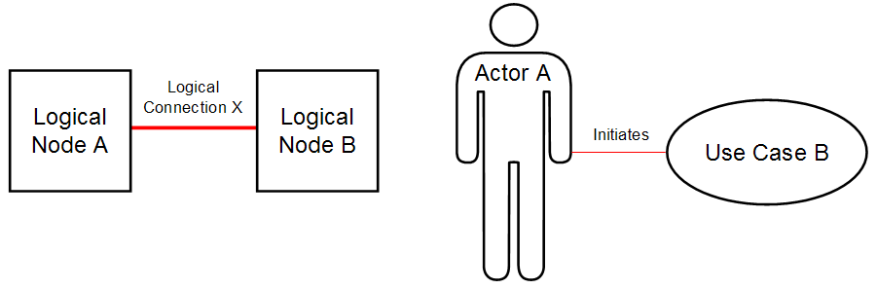
Figure 9: Connective model element symbol (left) and model element relationship (right)
Figure 9 highlights a connective model element (in this case, a logical connection between two nodes) on the left, and a model element relationship (showing an actor initiates a use case) on the right. The distinction may be clearer if – quite artificially, it is never drawn this way – the left hand view is redrawn with the model elements’ relationships explicitly shown:
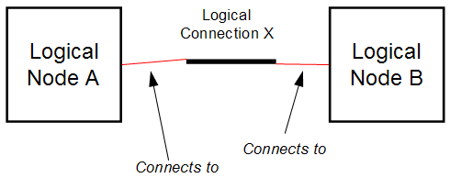
Figure 10: If the relationship between connective and nodal model elements was explicitly drawn
With one exception all lines in all of the operational viewpoint’s views are symbols of connective model elements (connections, borders, DU connectors and DU messages). However, the operational viewpoint’s diagrams do include “freeform lines”, that do not represent any part of the underlying model, but are used by the modeller for their own purposes and whose meaning must therefore be expressly defined on or near the diagram.

Target IT System
Target IT System: The IT system for which the model is being built
A target IT system’s symbols are shapes, icons or pictures

Core Notation
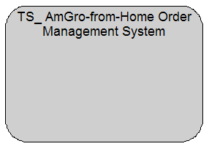
Figure 11: Target IT System (core notation)

Additional Options

Engineering Perspective - none
None

Visually Presented Information – picture icons
Pictures and other symbols may be used to represent target IT systems, such as:

Figure 12: Target IT System (additional option, pictorial icons)

Location
Location: A geographic place.
A location’s symbols are shapes, icons, or pictures

Core Notation
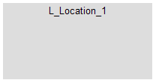
Figure 13: Location (core notation)

Additional Options

Engineering Perspective – logical and physical
Locations’ symbols may be labelled according to their engineering perspective, such as:
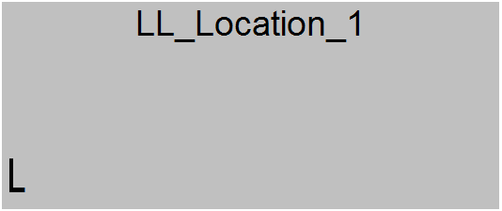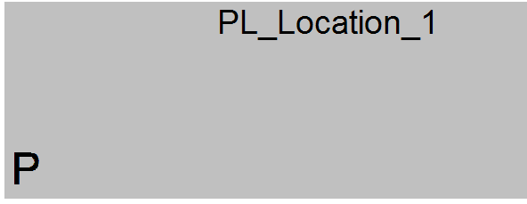
Figure 14: Location (additional option, engineering perspective examples: “logical” and “physical”)

Visually Presented Information - NFCs
Non-functional characteristics may be indicated, via colour coding or other means, such as:
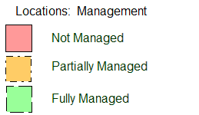
Figure 15: Locations (additional option, location characteristics)
In all cases the key must appear on the diagram and be fully defined in supporting text. For example Figure 15 indicates:
“Not managed”: All IT systems in this location are outside the control of the target IT system’s Systems Management processes and staff.
“Partially Managed”: Only some software elements are managed (such as application code running on a customer’s machine within a customer’s location)
“Fully Managed”: All IT systems in the location are fully under the control of the IT system’s Systems Management processes and staff.

Note:
Specific colour choice and style is not part of the notation. Colours and shading should be used with care, to avoid accessibility difficulties.

Visually Presented Information – picture icons
Pictures may be used to represent locations, such as:

Figure 16: Locations (additional option, pictorial icons)

Border
Border: The available connectivity between locations.
A border is between two locations – its symbols are lines

Core Notation
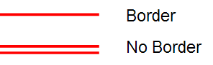
Figure 17: Border (core notation)
Note:
Specific colour choice is not part of the notation. Colours should be used with care, to avoid accessibility difficulties.
Borders may be drawn between locations in two ways:
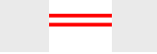
Figure 18: Border between locations (Location Model’s structure view)


Figure 19: Border between locations (Operational Model’s structure and walkthrough views)
It is usual for the notation in Figure 18 to be used on views in the Location Model, whereas the notation in Figure 19 is typically used in the Operational Model.

Additional Options

Engineering Perspective - none
None.

Visually Presented Information - NFCs
Non-functional characteristics may be indicated, via colour coding or other means, such as:
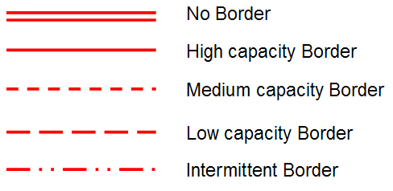
Figure 20: Borders (additional option, border characteristics)
In all cases the key must appear on the diagram and be fully defined in supporting text. For example Figure 15 indicates:
No Border: No connectivity available.
High capacity Border: High speed, Gb/s connectivity
Medium capacity Border: Moderate speed, 10’s Mb/s connectivity
Low capacity Border: Low speed, Mb/s connectivity
Intermittent Border: Connectivity must be established by the target IT system
Note:
Specific colour choice and style is not part of the notation. Colours and shading should be used with care, to avoid accessibility difficulties.

Zone
Zone: A sub-set of the target IT System with the same value for a chosen functional or non-functional property
A zone’s symbols are shapes, icons, or pictures.

Core Notation
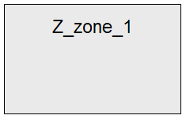
Figure 21: Zone (core notation)

Additional Options

Engineering Perspective - none
None

Visually Presented Information - NFCs
Non-functional characteristics may be indicated, via colour coding or other means, such as:
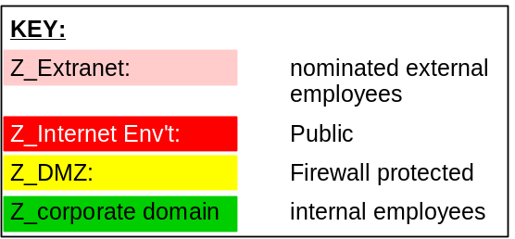
Figure 22: Zones (additional notation, zone characteristics)
In all cases the key must appear on the diagram and be fully defined in supporting text. For example Figure 22 indicates:
Extranet: Access limited to nominated employees of the client enterprise via userid and password.
Internet: Access available to all members of the public.
DMZ: Firewall protected to prevent uncontrolled external access to the internal network and uncontrolled internal access to the internet.
Corporate domain: Access available to all employees via userid & password.
Note:
Specific colour choice and style is not part of the notation. Colours and shading should be used with care, to avoid accessibility difficulties.

External Agent
External Agent: a human or IT system interacting with the target IT system via one or more access mechanisms, in order to perform one or more exchanges within the context of one or more roles.
An external agent’s symbols are shapes, icons, or pictures

Core Notation
External Agents’ core naming convention distinguishes logical actors from physical users:
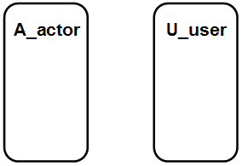
Figure 23: External agents (core notation, logical and physical)
It is also usual to distinguish “human” and “IT system” external agents (whether logical or physical):
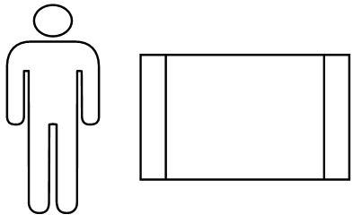
Figure 24: External agents (core notation, human and IT system

Additional Options:

Engineering Perspective – logical and physical
Symbols for logical external agents (referred to as actors) may be visually distinguished from those for physical external agents (referred to as users), for example:
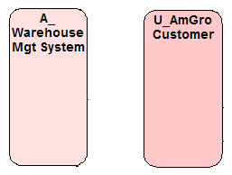
Figure 25: External agents (additional option, distinguishing Logical (left) and physical (right) by colour)
Or:
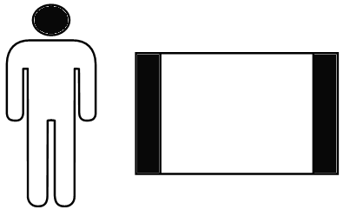
Figure 26: External agents (additional option, distinguishing actors (left) from users (right)
Or:
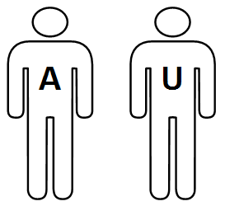
Figure 27: External agents (additional option, human actors (left) and human users (right)
Note:
Specific colour choice and style is not part of the notation. Colours and shading should be used with care, to avoid accessibility difficulties.

Engineering Perspective – located model elements
Symbols for located external agents may be visually distinguished from their non-located equivalents by an edging suggesting location, for example:
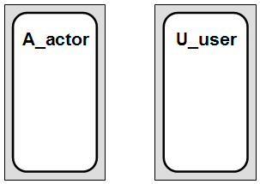
Figure 28: External agents (additional option, located actor, user)
Or:
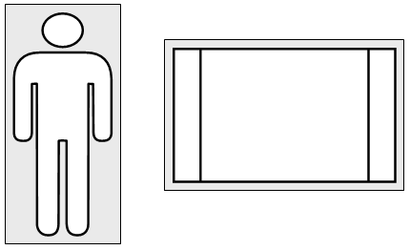
Figure 29: External agents (additional option, located human and IT system)

Visually Presented Information – picture icons
Pictures and other symbols may be used to represent external agents, such as:

Figure 30: External agents (additional option, human pictorial icons)
And:
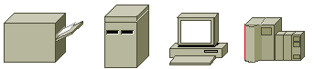
Figure 31: External agents (additional option, IT system pictorial icons)

Access Mechanism
Access Mechanism: the means whereby an external agent (human or IT system) accesses the target system
An access mechanism is between an external agent and the target IT system (System Context views) or between a located external agent and a located edge node (Operational Model views) - its symbols are lines.

Core Notation
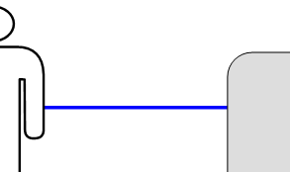
Figure 32: Access Mechanism (core notation, shown between human external agent and target IT system)
As well as external agents using more than one access mechanism, multiple external agents may use the same access mechanism. This latter case requires multiple symbols for the same access mechanism on the same view, and therefore the use of labels to ensure clarity:
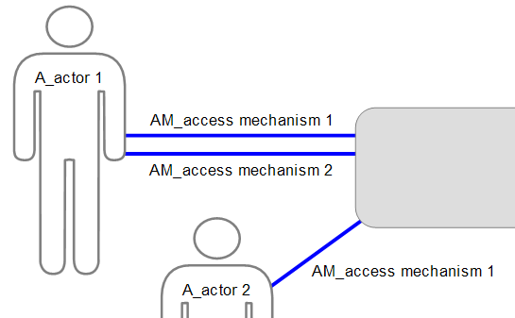
Figure 33: Access Mechanism (core notation, using labelling to avoid ambiguity)

Additional Options

Engineering Perspective – “one way traffic flow”
It may be appropriate to indicate when an access mechanism is uni-directional, such as paper output (via a printer) or a broadcast technology:
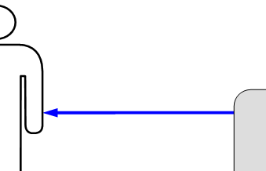
Figure 34: Access Mechanism (additional option, showing direction of flow)

Engineering Perspective – “multiple external agents”
A notation avoiding the need for multiple symbols when an access mechanism is being used by multiple external agents. Note that the thin lines between the access mechanism and the external agents are “relationship lines” as discussed in section “Connective elements’ symbols and element relationships”:
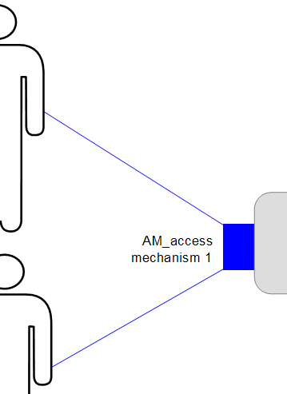
Figure 35: Access Mechanism (additional option, multiple external agents)

Visually Presented Information - NFCs
Non-functional characteristics may be indicated, via colour coding or other means, such as:
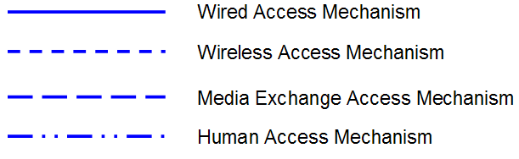
Figure 36: Access Mechanisms (additional notation, mechanism characteristics)
In all cases the key must appear on the diagram and be fully defined in supporting text. For example Figure 36 indicates:
Wired Access Mechanism: the IT system external agent is connected via a wired network
Wireless Access Mechanism: the IT system external agent is wirelessly connected
Media Exchange Access Mechanism: the external agent receives/sends physical media such as paper, CD, memory stick or tape
Human Access Mechanism: the human external agent uses a human-machine interface
Note: Specific colour choice and style is not part of the notation. Colours and shading should be used with care, to avoid accessibility difficulties.

Exchange
Note: Exchange is not observable from the Operational Viewpoint and therefore its symbol does not appear on any operational view. However, it’s presence on some of the System Context views, and it’s relationship with Access Mechanism mean it is helpful to include it here.
Exchange: What an external agent (Human or IT System does to, with or for the target IT system.
An exchange represents an aggregation of the conversation, data flows and/or other behaviors between an external agent and the target IT system, using an access mechanism to carry it between the two. For example, It may represent an aggregation of all or some of the flows between the external agent and the target IT system modeled in the Use Case Model. Its symbols are lines.

Core Notation
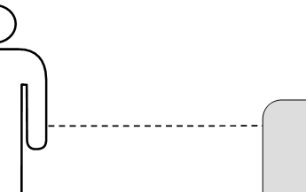
Figure 37: Exchange (core notation, shown between human external agent and target IT system)

Additional Options

Engineering Perspective - initiation
It may be appropriate to indicate the initiator of the exchange: the arrow head flows from the exchange’s initiator to the recipient:
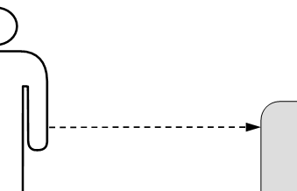
Figure 38: Exchange (additional option, showing direction of initiation)

Node
Node: An aggregation of co-located (or co-locatable) hardware and software components (which may be modelled as DUs), intended to operate as a cohesive whole. Physical nodes are things like computers, terminals, printers, routers and other devices. Logical nodes describe what these physical devices do (or are intended to do).
A node’s symbols are shapes, icons, or pictures

Core Notation
On structure views with multiple nodes (e.g. views in which nodes are linked via connections):
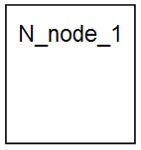
Figure 39: Node (core notation, structure views)
On walkthrough views showing the exchange of messages between nodes, when drawn as “sequence diagrams”:
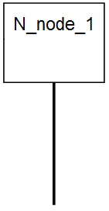
Figure 40: Node (core notation, walkthrough views)
On a Node Box Diagram:
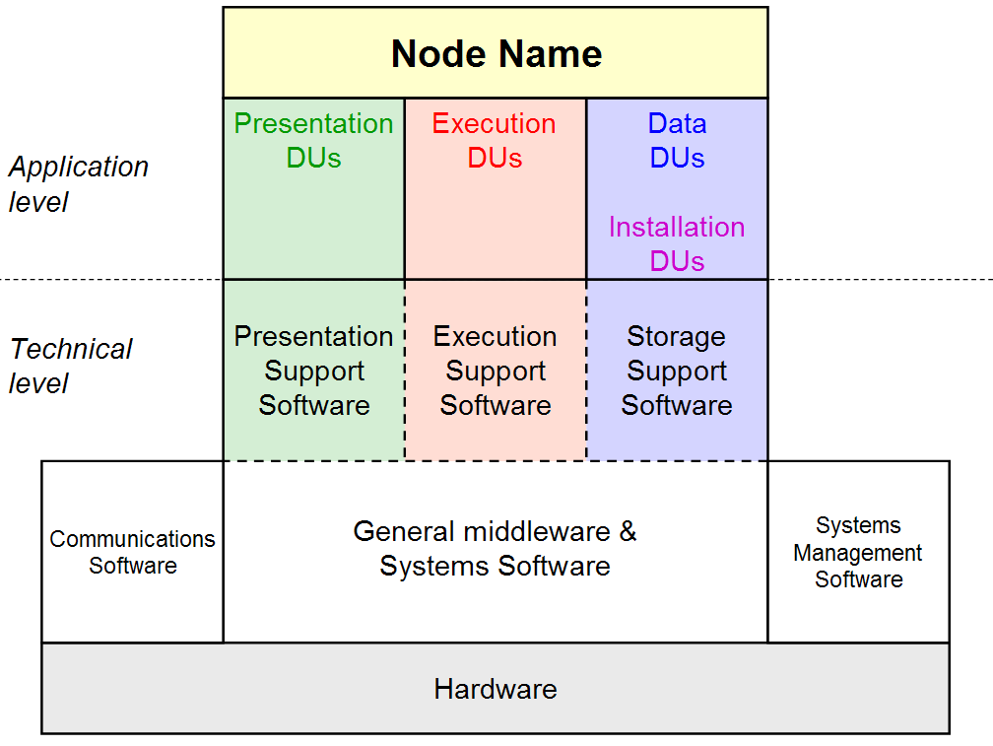
Figure 41: Node (core notation, node box diagram)

Additional Options

Engineering Perspective – located model elements
Symbols for located nodes may be visually distinguished from their non-located equivalents by an edging suggesting location, for example:
:
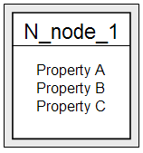
Figure 42: Node (additional option, located node)

Engineering Perspective – physical external node
Physical deployment of part of the target IT system onto an existing external IT system is modelled via an “external node”:
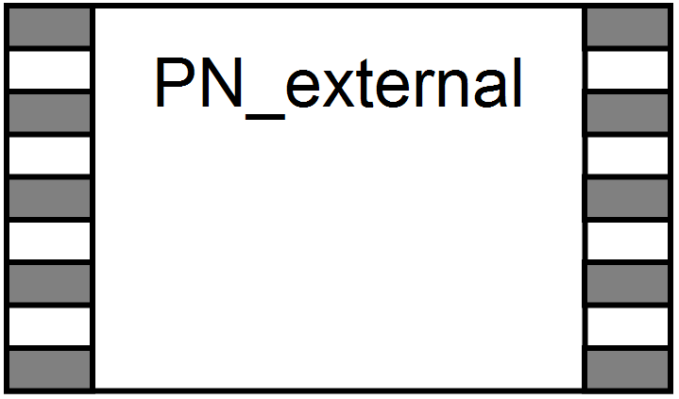
Figure 43: Node (additional option, physical external node)

Engineering Perspective – labelled by perspective
Nodes’ symbols may be labelled according to their engineering perspective, such as:
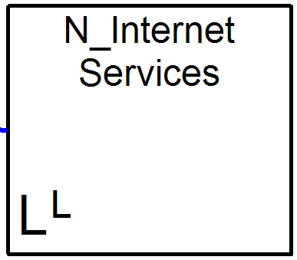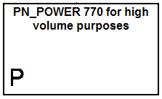
Figure 44: Node (additional option, explicit engineering perspective (e.g. “logical located” and “physical”))

Visually Presented Information – composed of DUs
On views with multiple nodes, the DUs which make up the node may be indicated:
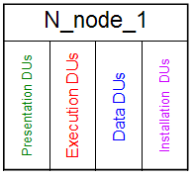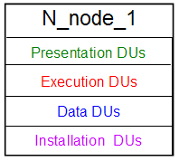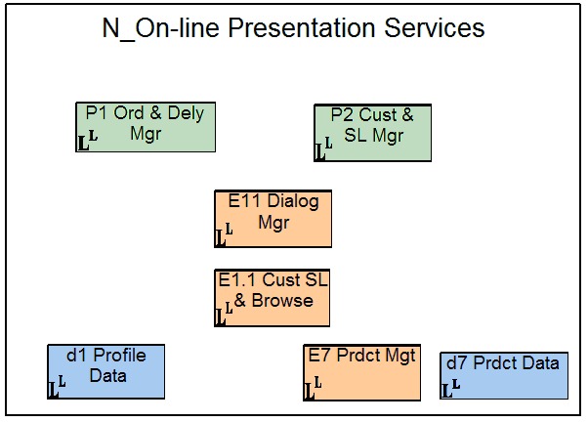
Figure 45: Node (additional option, showing Node’s DUs)

Visually Presented Information – picture icons
Pictures and other symbols may be used to represent nodes, such as:
Figure 46: Node (additional option, pictorial icons)

Visually Presented Information – 3D symbols
Some tools, such as those adhering to UML, represent nodes thus:
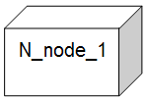
Figure 47: Node (additional option, 3D node)

Connection
Connection: The required connectivity between nodes, needed to support interactions between components’ DUs on those nodes.
A connection is between two nodes – its symbols are lines

Core Notation
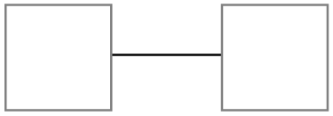
Figure 48: Connection (core notation, shown between nodes)

Additional Options

Engineering Perspective – physical connections
Logical connections are “point to point” between exactly two nodes, as shown in Figure 48. However, physical connections are “multipoint”, between any number of nodes, and may therefore be drawn in a number of ways, such as those shown in Figure 49 and Figure 50:
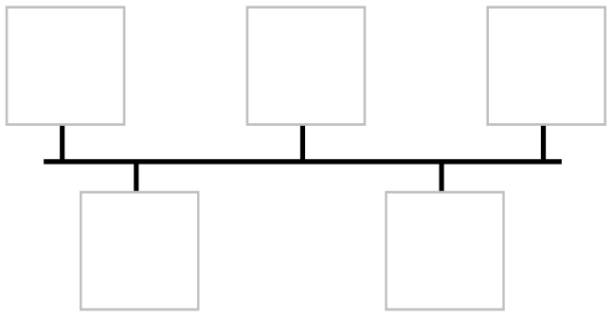
Figure 49: Physical connection example (“multidrop”)
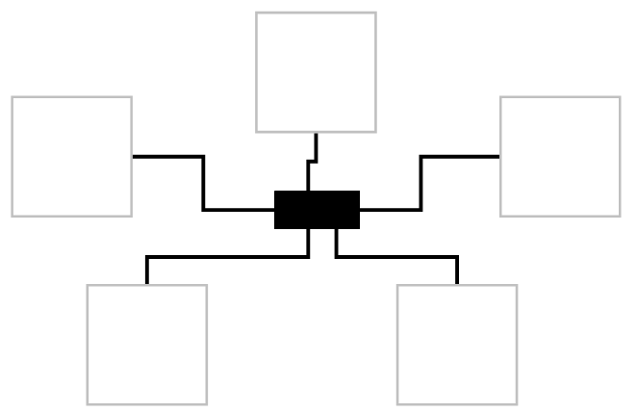
Figure 50: Physical connection example (“hub and spoke”)

Visually Presented Information - NFCs
Non-functional characteristics may be indicated, via colour coding or other means, such as:
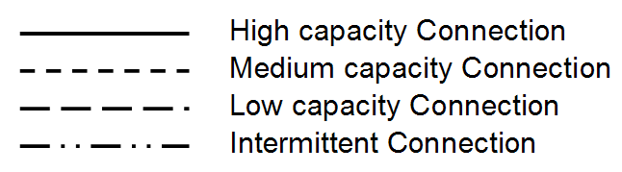
Figure 51: Connections (additional notation, connection characteristics)
In all cases the key must appear on the diagram and be fully defined in supporting text. For example Figure 36 indicates:
High capacity Connection: High speed, Gb/s connectivity
Medium capacity Connection: Moderate speed, 10’s Mb/s connectivity
Low capacity Connection: Low speed, Mb/s connectivity
Intermittent Connection: Connectivity must be established by the target IT system
Note:
Specific colour choice and style is not part of the notation. Colours and shading should be used with care, to avoid accessibility difficulties.

Visually Presented Information – “hub and spoke” physical connection
Pictures and other symbols may be used to represent a physical connection when drawn in a hub-and-spoke style, such as:
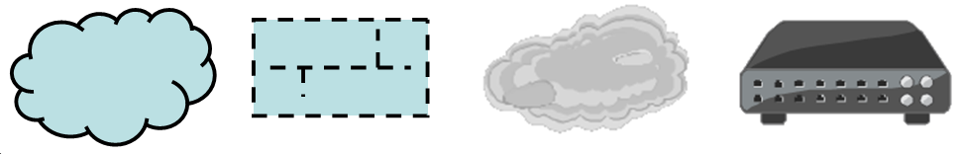
Figure 52: Physical Connection (additional option, pictorial icons)
Leading, for example, to:
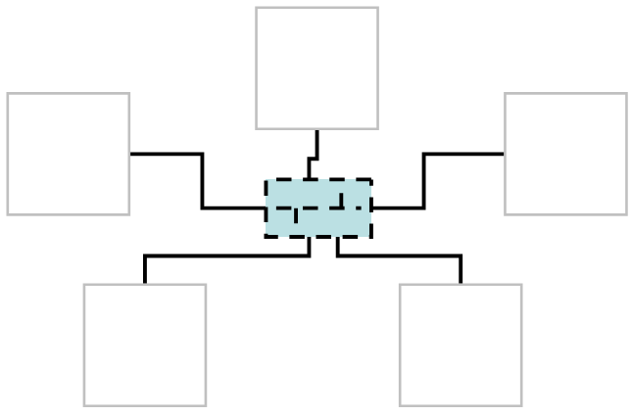
Figure 53: Physical Connection example (additional option, “hub and spoke” pictorial icon)

Deployment Unit
Deployment Unit: Represents one of four deployment aspects of a component: presentation, execution, data and installation
Only located DUs are represented by symbols on views. These symbols are shapes, icons, or pictures

Core Notation
On structure views, when drawn “inside” nodes:
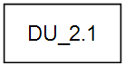
Figure 54: Located DU (core notation)
Greater clarity may be achieved using the following standard prefixes for Located DU names (following the same short and long form approach documented in section “Element Naming (All Model Elements)”):
- Presentation DU: P<x> or P_<x>
- Execution DU: E<x> or E_<x>
- Data D DU: D<x> or D_<x>
- Installation DU: I<x> or I_<x>
Note:
Specific colour choice and style is not part of the notation. Colours and shading should be used with care, to avoid accessibility difficulties.

Additional Options

Engineering Perspective – labelled by perspective
Located DUs’ symbols may be labelled according to their engineering perspective, such as:

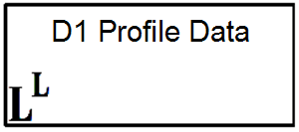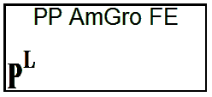
Figure 55: Located DU (additional option, logical Located and physical located”)

Visually presented Information – “master/copy” DUs
An upper- and lower-case prefix naming convention is available for visual “clues” on some characteristics of located DUs such as:
Located DU type | Prefix | Meaning
Presentation DU | P_ | Preferred or “normal” location of access
 | p_ | Alternative or “degraded service” location of access
Execution DU | E_ | Preferred or “normal” location of execution
 | e_ | Alternative or “degraded service” location of execution
Data DU | D_ | Master version of data
 | d_ | Copy or replica (may be informational or operational)
Installation DU | I_ | Normal source from which executable is loaded
 | i_ | Alternative source from which executable is loaded
Other naming notations may be used for located DUs:
- Data:
  - A “dotted decimal” numeric identifier, such as D1.1 and D1.2 to indicate two located data DUs containing parts (split by “column”) of data DU1.
  - (s) suffix, such as D1(s), to indicate a located data DU containing part (by row) of data DU D1.
- Execution
  - (s) and (c), such as E1(s) and E1(c) to indicate a client-server deployment of execution DU E1

Visually Presented Information – components’ aspects
The component’s aspect represented by the DU may be indicated, such as:

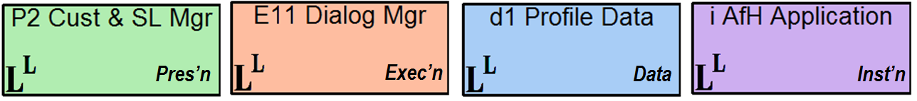
Figure 56: Located DU (additional option, DU types: “presentation”, “execution”, “data” and “installation”)

Note:
Specific colour choice and style is not part of the notation. Colours and shading should be used with care, to avoid accessibility difficulties.

DU Connector
DU Connector: Transport mechanism for DU messages between located DUs. A DU connector is conveyed over inter-node connections when the involved DUs are on different nodes.
A DU connector is between two located DUs – its symbols are lines

Core Notation

Figure 57: DU connector (core notation, shown between two located DUs)

Additional Options

Engineering Perspective - none
None.

Visually Presented Information - none
none

DU and Freeform Message
DU Message: A single communication, consisting of either a package of information or transfer of control between DUs or between a DU and an external agent.
Freeform Message: An approximate communication between nodes or between a node and an external agent, representing one or more underlying (often unmodelled) DU messages between DUs implied to be present on each node
DU and freeform messages are between two things - in all cases their symbols are lines.

Core Notation

Figure 58: DU or freeform message (core notation)

DU messages may be drawn between DUs (or nodes) in two ways:

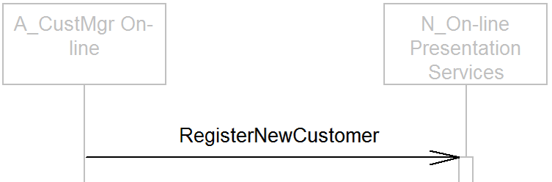
Figure 59: DU or freeform message on a walkthrough “sequence” view

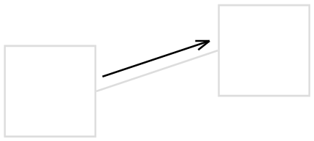
Figure 60: DU or freeform message on walkthrough “collaboration” view
Note that the notations on Figure 59 and Figure 60 are appropriate for DU messages between located DUs (in which case Figure 60 shows the message “carried” by a located DU connector), as well as freeform messages between located nodes (in which case Figure 60 shows the freeform message “flowing over” a located node connection).

Additional Options

Engineering Perspective - none
None.

Visually Presented Information – Focus of Control
For some or all of the time between the receipt and subsequent transmission of messages, actors and DUs may “do something” (such as when an EDU is executing, or an DDU retrieving information). This may be signified via a focus of control drawn on the actor or DU instance symbol:

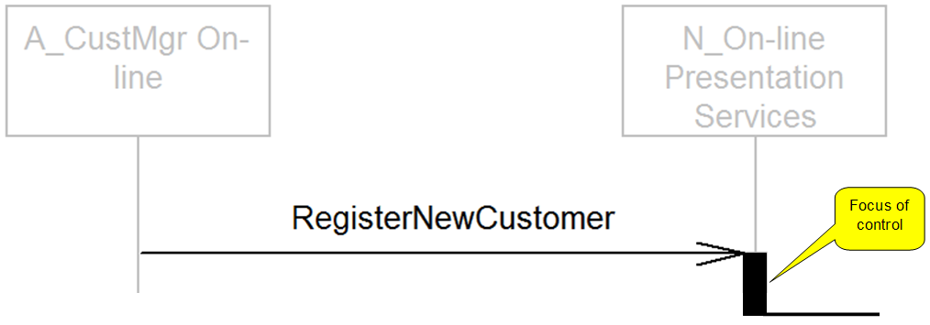
Figure 61: Focus of Control on a walkthrough “sequence view

References
Some of these are referred to in the body of the document; others provide examples and further reading:

- “SDS R3: Views Notation for the Operational Viewpoint”; Ian Charters (2012)
To be reference by Tom Seevers
- “System Description Standard R3: Semantic Specification”; Philippe Spaas (2008)
https://w3.tap.ibm.com/w3ki/display/SDSR3/SDS+R3+Semantic+Specification
- “An Introduction to the IBM Views and Viewpoints Framework for IT Systems”; Denise Cook, Peter Cripps, Philippe Spaas (2008)
http://www.ibm.com/developerworks/rational/library/08/0108_cooks-cripps-spaas/
- “Team Solution Design White Paper: ‘Operational Modelling’”; Ian Charters (2012)
To be reference by Tom Seevers
- “Team Solution Design White Paper: ‘System Context Modelling”; Ian Charters (2009)
http://gcd.ibm.com/RMCPlugins/TeamSolutionDesign/index.htm#core.tech.common.extend-ibm_int/guidances/whitepapers/system_context_modeling_8F09CE95.html
- “Architectural Thinking Class, AmGro-from-Home Case Study”; Ian Charters (2012)
- This is available to alumni of the class. An awareness level case-study, much of the material is presented by the “Architectural Thinking” course’s instructors.
- “TLU College 2, AmGro-from-Home Case Study”; Ian Charters (2011)
- This is available to alumni of the class. A technique level case study, much of the work is done by students.
- “AmGro-from-Home OMS sample encyclopaedia for SA4TeamSD”; Ian Charters (2012)
- Available to users of the SA4TeamSD configuration of Rational System Architect. For access, contact your Business Unit’s Deployment Contact, via
http://w3-03.ibm.com/support/tsdesign/tooling.html

Version Information

Revision Number | Revision Date | Summary of Changes | Author
V3.0 | July 2012 | Thorough revision to encompass evolution of SDS R3 (from ADS R2). Contemporary with “SDSR3: Views Notation for the Operational Viewpoint” | Ian Charters
V2.0 | March 2002 | Called “ADS Operational Model Notation V2” | Ian Charters

In this document pictorial representations are called views if they present a faithful rendering of the underlying model – i.e. all symbols represent methodologically defined elements or relationships. If, however, a representation is more sketch-like, in which the meaning of one or more symbols is not formally defined, then it is referred to as a diagram.
Such as a set of cross-indexed spreadsheets, a database or set of hierarchically organized files – whether as part of a Computer Aided Design Tool or as part of a manually managed modelling environment.
In this regard, the elements that appear on the operational viewpoint’s views are found in the SDS “IT System Operational ” package.
From the UMF “Operational Model (ART 0502)” Artefact. As at April 2012, the language used in this artefact description predates that used in this document, as well as many of the references cited. For example, the “operational aspect” is now refered to as the “operational viewpoint”.
Explanation is beyond the scope of this paper. See [Ref 4]
An “alternative option” for access mechanisms when used by multiple external agents
Note that his convention was adopted shortly after the publication in 2002 of V1 of this paper. There may therefore be older materials using the previous convention of U for presentation (u=user) and P for execution (p=processing).

